
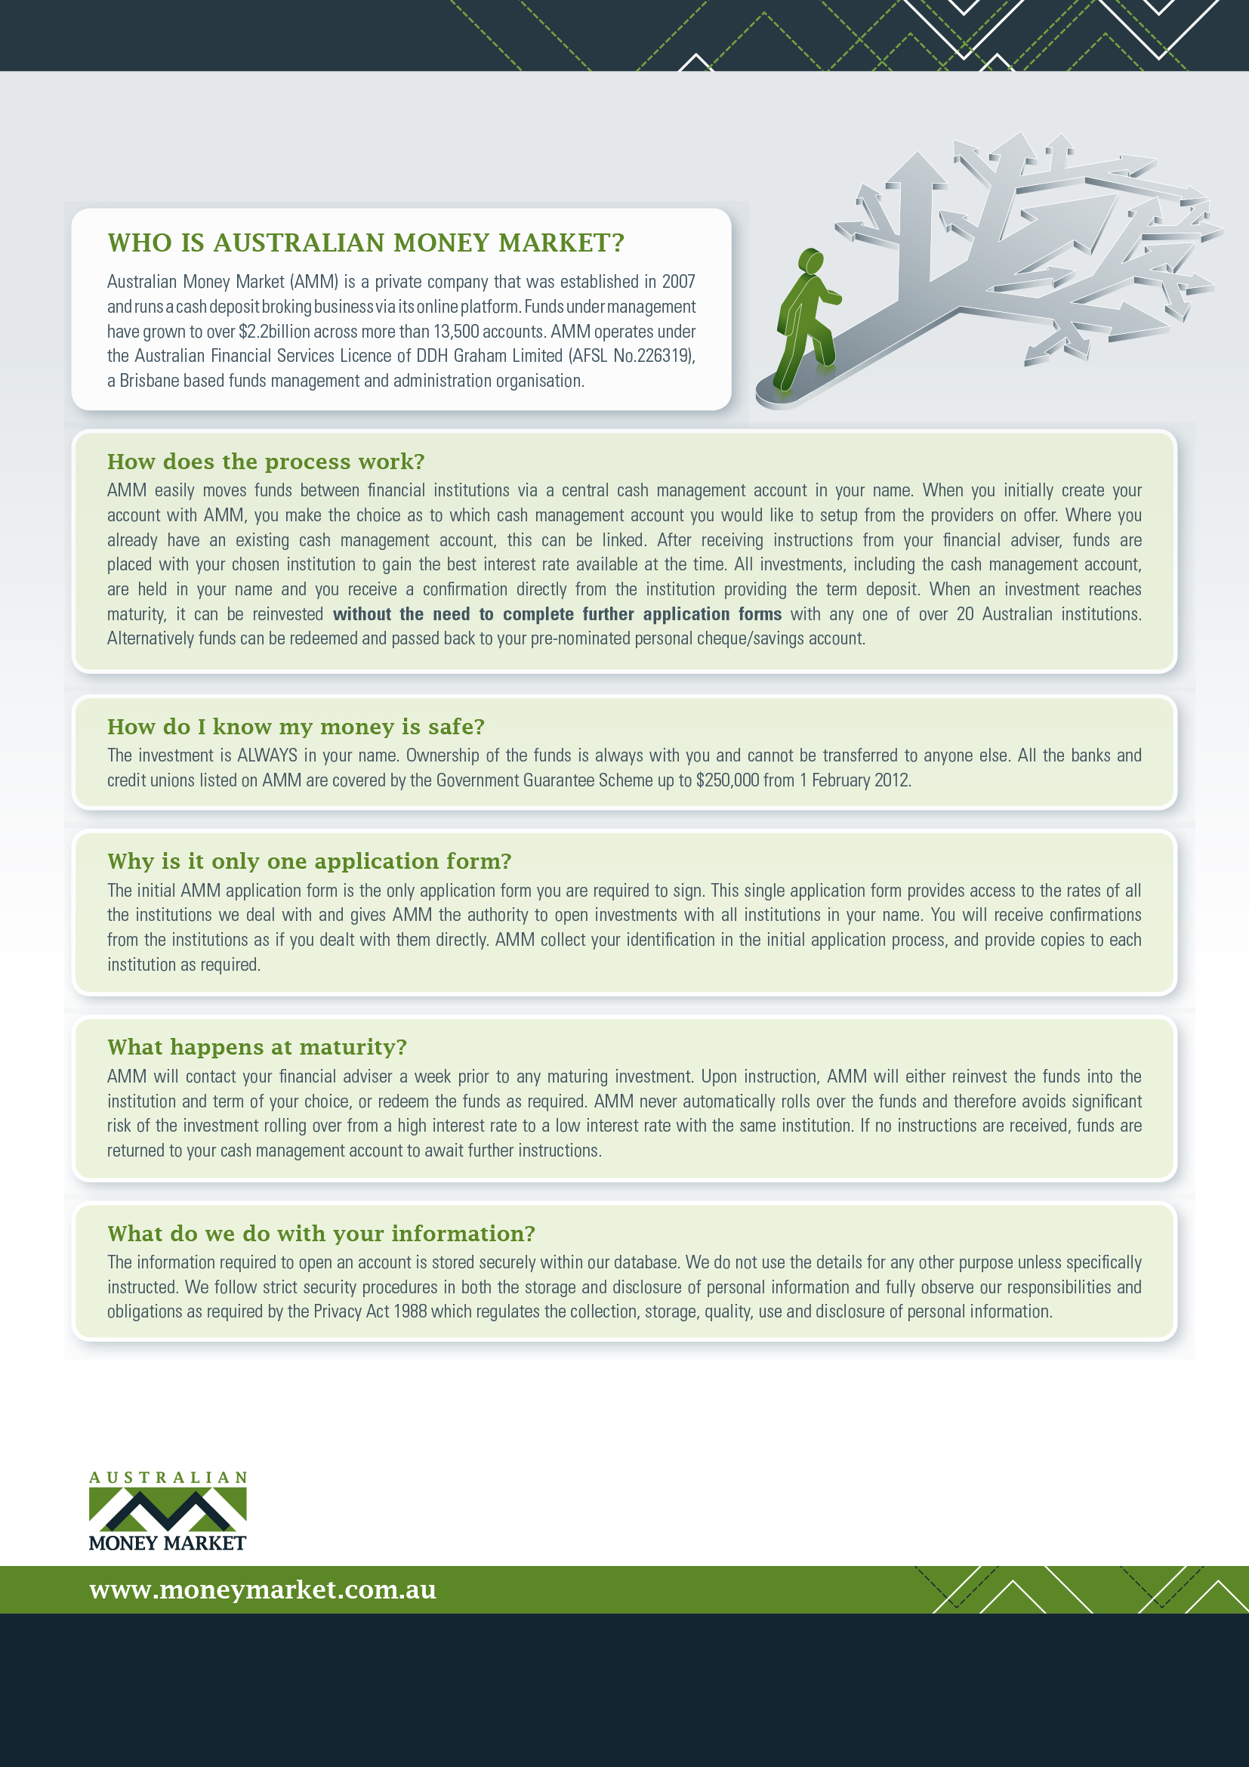
Address Line 1
Address Line 2
Tel: (00) 0000 0000 • Fax: (00) 0000 0000
Email: address here

